Quick Start Guide
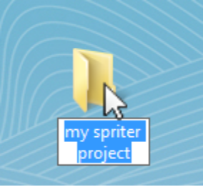
Step 1) Create a folder for your new Spriter project and name it whatever you'd like.

Step 2) Within that project folder, create as many additional folders you'll need to keep all of the images you'll be using the create the animations. Then place all of the images in these folders. They MUST BE PNG format.
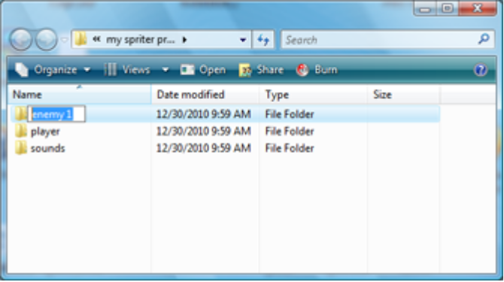
Step 3) If you will be triggering sounds in your Spriter project as well, create a folder in the main project folder called “sounds”. It MUST be exactly named “sounds” to function properly. Then place all of the sounds you will be using in this folder.

IMPORTANT NOTE FOR STEPS 3 AND 4: All image folders and the sound folder must be directly within the main project folder, no sub folders can be used. The same is true for the sound folder.

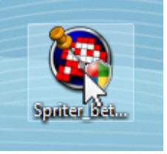
Step 4) Open Spriter by double clicking on the Spriter.exe icon. Spriter what ask you what you want to do. If you're creating a project from scratch, choose “Start a new project”, then use the file creation dialogue that will appear to create your Spriter project file in the main project folder you had created in step 1. Name the project file whatever you'd like.

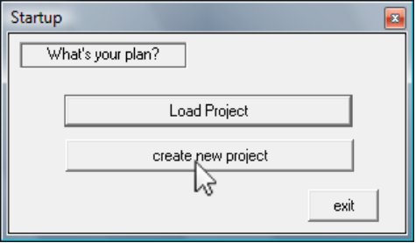

Step 5) Spriter's editing interface windows will appear so you can begin working. You can see that it has created your Spriter file with a first Character, animation, and frame so that you can get started. To stay organized you may want to rename each of these to better reflect what you'll be working on.

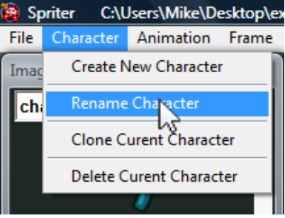
To rename the character, choose Character, Rename Character from
the main menu.

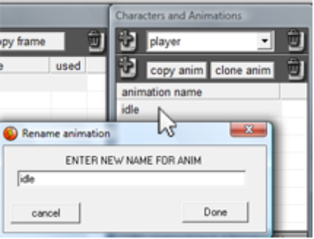
To rename an animation, simply double click the name of the animation in the animation list in the “Character and Animations” window.

Similarly, to rename a frame, double click on the name of the frame in the frames list in the “Frames List” window.

Step 6) Now that you're organized its a good idea to save your progress. To save your Spriter Project, either hold Ctrl and press the “S” button or select File/Save from the main menu.

Step 7) To begin creating an actual frame for your character you will need to choose an image to place into the frame. You can select any of the folder images that you had created and populated with your images in step 2 in the roll down list at the top left of the “Image Parts” window. Then left click on the first image you'd like to place in your frame.

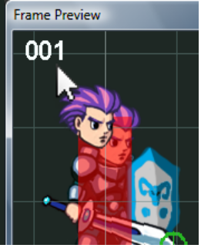
Now move your mouse onto the “Frame Preview” window. This is where you will edit your frame. You should see the image that you had clicked on following your mouse. Position the image where you want it and place it into the frame by left clicking once more.

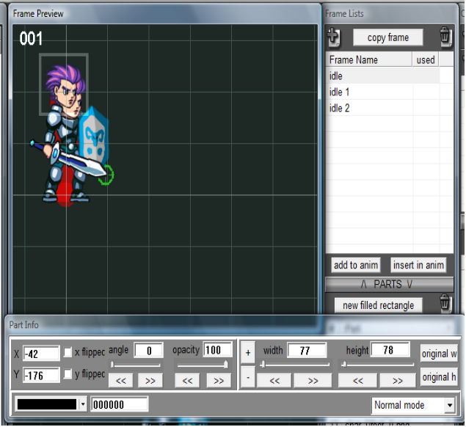
Step 8) Once the image is placed it should be automatically selected..you will see a flashing rectangle surrounding the image. By default a new window will also appear with buttons and other controls to change a great many aspects of the image such as its position, width, height, opacity, drawing mode etc. You can use this window to make whatever changes would like to the image. All of the important changes can also be made using shortcut keys which I highly recommend you learn as quickly as possible to drastically increase your work flow. This “Part Info” window can even be set to no longer appear once you no longer have need of it. (View/Show Part Info Editor When One Object Is Selected)

Step 9) To get the most out of the modular system of animating that Spriter was made for, you'll likely want to repeat Steps 7 and 8 to add additional images to create the finished frame. Inevitably you'll have a need to adjust the order in which these images are drawn (z order)... To do this, simply select the image who's z-order you want to change, hold the Ctrl key and tap either the up or down arrow as many times as necessary to arrive at its desired z-order. You may also sometimes want to delete an image that you've place in a frame. For that, just select the image by left clicking on it and then press the Delete key.

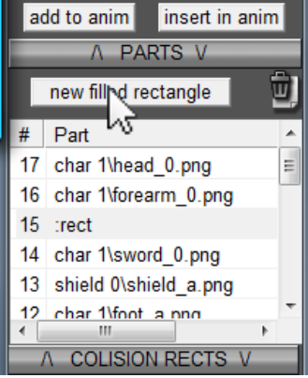
Step 10) Sometimes you might only need a simple block of color as part of a frame, for this Spriter also allows you to add (and even stretch and rotate) solid rectangles of any color to your frame. These “Filled Rectangles” can be used exactly like images in a frame. You can also delete them or change their z-orders using the same method as for the images. To create a filled rectangle, just click the “new filled rectangle” button above the “Parts” list in the “Frame List” window.

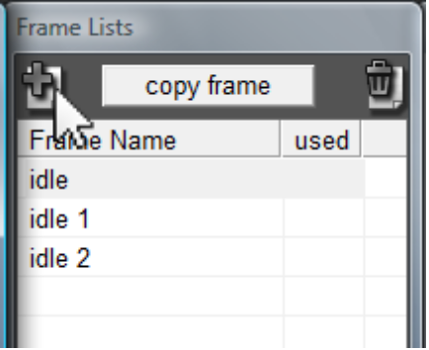
Step 11) Now that you've created a frame, you'll need to create at least one more in order to have an animation that actually animates. You can either begin creating a new frame from scratch by clicking on the “Create Frame” Icon located at the top left of the “Frames List” window, or you can start your second frame off as a copy of your first frame. This is often much faster and more convenient as frequently the frames of an animation only require subtle changes from one two the next. To copy a frame, just single-click on the name of the frame in the frame list in the “Frames List” window and then click the “copy frame” just above the frame list.

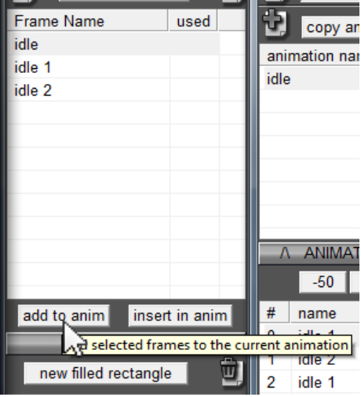
Step 12) Now that you have some frames, you need to add them into your animation. To do so simply select one or more frames in the Frame List I the “Frame List” window and then click either the “add to anim” or “insert in frame” buttons. The “add to anim” button will add the selected frames to the bottom of the animation while the “insert in anim” will insert these frames starting at the position of the current frame you have selected in the “Animation Frames” list in the “Character and Animations” window.

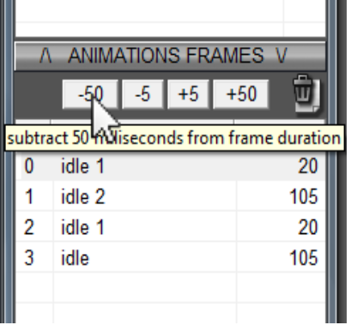
Step 13) Once you have added frames into an animation you'll likely want to tweak the duration that each frame will be visible in the animation. This is done with the “-50”, “-5” ,“+5” and “+50” buttons just above the “Animation Frames” list in the “Characters and Animations” window. Clicking these buttons will increase or decrease the duration of any of the frames you have selected in the “Animation Frames” list.

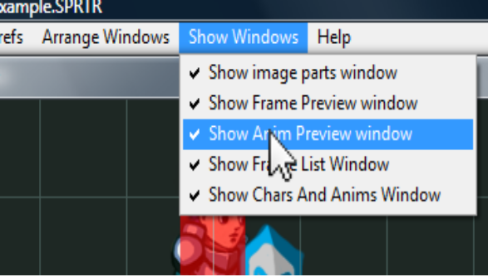
Step 15) To make sure your animation is perfect, you'll want to preview it in the “Anim Preview Window. Simply make sure the “Anim Preview” Window is visible (menu option under Show or Hide Windows), then select a single animation in the “Animations” list in the “Character and Animations” window. (You should then see the first frame of the animation in the “Anim Preview” Window). Then simply press play to see your animation.

Step 16) Explore the more advanced features! Now that you know how to do the basics, read the other chapters of the help doc to learn of the other cool features like triggering sound effects, variable changes, and adding collision rectangles and action points to frames. There's also “Character Maps” to truly get the most out of your art and animation data. Good luck.

